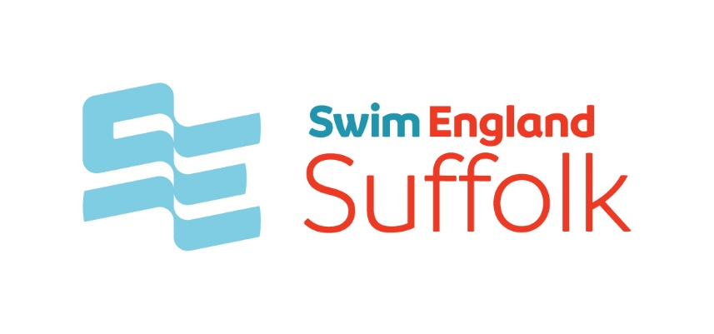
Swim England Suffolk County
County Championships 2023 Merchandise
After the success of last year, we are again offering the opportunity to purchase a County Championship’s hoodie. This year, there is also the option to have a name on the reverse of the hoodie.
Orders will be placed with the manufacturer every Friday up to and including 10th February. Where possible, hoodies will be delivered to clubs at Crown Pools.
Hoodies will be steel grey and are available in the following sizes:
Child sizes: 9/11 32”; 12/13 34”
Adult sizes: XS 34”; S 36”; M 40”; L 44”; XL 48”; 2XL 52”
Hoodies with a name on the back will cost £20; hoodies with a plain back will cost £18.
To order a hoodie, please return this form with the required information to sesuffolk.hoodies@outlook.com and make payment using Swim England Suffolk PayPal account https://paypal.me/SwimEnglandSuffolk?country.x=GB&locale.x=en_GB
When making your payment, please include the name of the swimmer for reference.
Name
Club
Hoodie size required
Name on reverse
I confirm that I have made payment to the Swim England Suffolk County PayPal account

